Assignment 4

# Part 1

## Output from enum_gpu.cu

## Output from set_gpu.cu

## Output from simple_kernel.cu

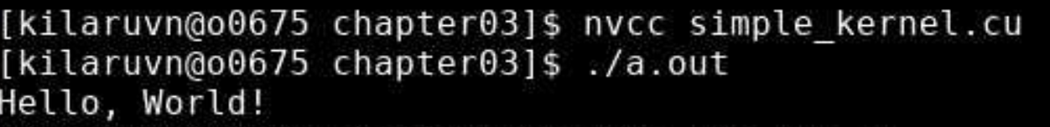

## Output from hello_world.cu

## Output from simple_device_call.cu



## Output from simple_kernel_params.cu

## 

# Part 2

## Original Image

## Resulting Image

